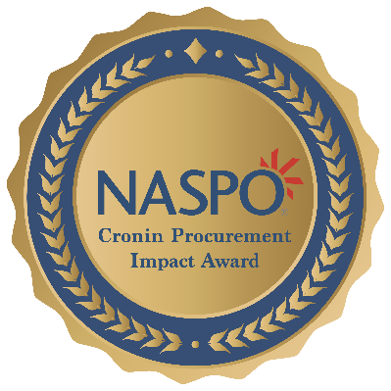
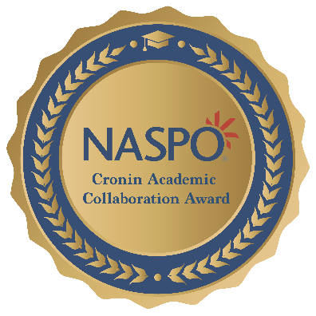
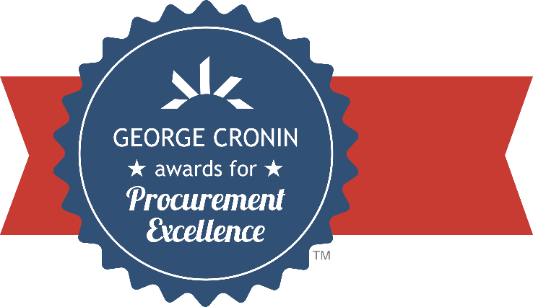

State of (Insert Name)
Department of (Insert Name)
Division of (Insert Name)

2026 NASPO
CRONIN AWARDS:
George Cronin Awards for Procurement Excellence
Cronin Procurement Impact Award
Cronin Academic Collaboration Award

Enter Submission Title Here

This is the official template for submissions for the George Cronin Awards for Procurement Excellence, the Cronin Procurement Impact Award, and the Cronin Academic Collaboration Award. Use this comprehensive template to guide you as you prepare your submission for review by the Awards Committees. This text may be deleted from your completed submission.

General Instructions
This is the official template for submissions for the George Cronin Awards for Procurement Excellence, the Cronin Procurement Impact Award, and the Cronin Academic Collaboration Award. Use this comprehensive template to guide you as you prepare your submission for review by the Awards Committees. Please delete this guideline text as you go through this template; it is just there to help you understand the criteria that the committees will use for evaluation.
You must use this template to submit for any of the three awards programs (George Cronin Awards for Procurement Excellence, Cronin Procurement Impact Award, and Cronin Academic Collaboration Award). You may create one submission per highlighted procurement project/initiative for consideration for any of the three awards or any combination thereof. You may create separate submissions, tailored to each award, for your project (1 project, multiple submissions – 1 for each desired award). Alternatively, you may submit a single comprehensive entry for multiple awards if your project or initiative meets the criteria for each. Note: the terms “project” and “initiative” are used interchangeably throughout this template.
You will indicate your targeted awards when uploading your completed submission on the Cronin Awards page on the NASPO website.
Please fill in the appropriate State, Department, Office, and Title information on the cover page. The succeeding pages in this document outline the criteria and specific instructions for each award. Submissions should be organized and structured according to the requirements for the specific awards, offering information relevant to the listed criteria. Submissions are limited to five (5) pages (excluding the cover/title page), and optional supporting material may be submitted as a separate document when needed to showcase images, examples, or documentation that is too large to fit within the five-page submission. Please keep font size and color within normal business expectations – no smaller than 10pt.
Appending Supplemental Exhibits:
Aforementioned supplemental materials may be appended to your submission, if necessary, to showcase images, examples, or documentation (templates, forms, reports, etc.) that is too large to fit within the five-page submission itself. Exhibits can be uploaded to the submission portal on the Awards page. Supplemental exhibits larger than five pages should be hosted on a website and made available for viewing and/or downloading by committee members via a link embedded in your submission document.
Please note that committee members are not required to carefully peruse voluminous supporting materials to properly understand or appreciate the nature and scope of the project. The five-page submission should make this clear on its own. Supporting materials should do just that—support and demonstrate the statements made and results described in the five-page submission itself - and should only be used when necessary.
Uploading Your Submission:
Once you are finished with your submission, you can export it as a PDF and upload it to the Cronin Awards page using our online form. Use the checkboxes in the upload portal to indicate which awards you would like your submission considered for. You must have the consent of your CPO/NASPO Primary Member to submit for these awards and indicate their consent by checking the appropriate box when uploading your submission.
Upload your submission here: https://www.naspo.org/awards/george-cronin-awards/how-to-apply/

The George Cronin Awards for Procurement Excellence
The George Cronin Awards for Procurement Excellence evaluation consists of four criteria categories, each weighed separately to produce an overall score. The scoring methodology used is a two-phased approach:
Phase 1: The committee will score only the Innovation and Transferability criteria categories, after which a “Top Ten” will be named based on those scores.
While conducting Phase 1 evaluations, the committee may develop questions to clarify elements of the submission. NASPO committee support staff will reach out to the individual who uploaded the Cronin Award submission to request written responses to any committee questions.
Phase 2: The ten highest-scoring submissions from Phase 1 will proceed to Phase 2. The committee will evaluate those submissions for the remaining two criteria categories, Service Improvement and Savings & Efficiency.
Phase 1 and Phase 2 scores are aggregated, and final scores are calculated. The five highest total scores are identified as finalists, and the final rankings are revealed during the awards ceremony at NASPO’s Annual Conference.
States may submit up to 3 separate projects/initiatives for the Cronin Awards for Procurement Excellence.
When creating your submission, it is recommended that you include 5 specific sections – a summary, and one section for each criteria category: Innovation, Transferability, Service Improvement, and Savings & Efficiency.
Executive Summary
It is useful to committee members for a submission to begin with a concise introduction/executive summary that describes the purpose and scope of the project and gives a narrative overview of the development and implementation process. If there is anything in the submission to which committee members should pay particular attention, it is helpful to mention it in the introduction. This summary is included as part of the total page limit for the submission.
Innovation
(30% of Total Score) – This category should answer the question, “What makes this project stand out as a notable contribution to the procurement function?” This category recognizes procurement initiatives that demonstrate exceptional originality, creativity, and problem-solving. Submissions should highlight projects that significantly advance the procurement function through unique approaches, transformative scale, or groundbreaking concepts.
It is intended to capture the innovative nature and impact of changes in your state operations, but it also rewards path-breaking ideas or efforts that may not have been considered or attempted elsewhere – for example, developing a novel solution to a common issue. Because substantial originality is so rare, this category rewards a submission that can identify differences and distinguish itself from closely similar projects underway or completed in other states.
Transferability
(30% of Total Score) - Primarily an external focus, this category should explain how the submitted project may be adapted or adopted by other states or entities. Transferability assesses the practical ability of other states to replicate or use the submitted project as a model or benchmark, taking into account the expected resources required and the generality of the legal or structural environment in which the project was implemented.
A project or initiative that can be broadly used by other states as a template will receive a higher score than one with benefits that appear to depend on the particular geography, environment, governmental structure, or needs of the submitting state. It may be necessary to explain how an apparent state-bound effort can be adapted for greater transferability.
Service Improvement
(25% of Total Score) – This category is an internal focus that assesses the extent to which procurement functions, support, transactions, or service delivery are made more effective or efficient. This includes consideration of the nature of stakeholder involvement by agencies/users in the development and implementation of a program or project. It may also include any change management strategy sufficient to promote adoption. Committee members look favorably at descriptions of the input, participation, and adoption by stakeholders.
Every purchasing organization provides a service to other state agencies, and this category is intended to assess results—the impact of the project on improving the delivery of those services. More weight is given to specifics than to generalities. When metrics are provided, it is beneficial to include a short (non-technical) explanation of how those metrics were produced.
Savings & Efficiency
(15% of Total Score) – This category focuses on validated or potential for cost reduction, resource savings, and improved efficiency. Although this savings criterion may not be as highly weighted as the other three categories, well-documented estimates or projections of savings are often the determining factor between otherwise comparable submissions.
Savings and efficiency figures are given more weight when they are objective, supported by evidence, and include an explanation of how they were derived. Although increases in efficiency are less open to precise calculation, the manner or method by which the increase is realized should be described. In general, undocumented claims of very large cost reductions are less likely to receive high scores than smaller, well-supported cost-savings estimates.

The Cronin Academic Collaboration Award
This award celebrates exceptional partnerships between state procurement agencies and academic institutions that foster mutual growth, innovation, and the development of future public procurement leaders. It acknowledges collaborations that transcend traditional boundaries, create opportunities for students, and enhance the efficiency and effectiveness of public procurement.
Guidelines for qualifying submissions:
- The initiative demonstrates innovative contributions to either the state office, academic partner, or both entities.
- The outcomes (or anticipated outcomes) from the collaboration are measurable and mutually beneficial.
- There is evidence of mutual growth or contribution to the profession as a result of this collaborative partnership. (i.e., mentorships, internships, curricula, research, guest lectures, etc.)
- The initiative must have been launched within the preceding 5 years.
- Only one submission for the Academic Collaboration Award per state is permitted.
The Academic Collaboration Award is evaluated by a sub-committee of procurement professionals, higher education administrators, and academic professionals. The subcommittee’s scoring process will identify two finalists, and the winner will be selected by member vote.
States may submit 1 project or initiative for the Cronin Academic Collaboration Award.
When creating your submission, it is recommended that you include sections addressing these specific criteria: Executive Summary, Innovation, Outcomes, and Areas of Mutual Growth
Executive Summary
- Describe how the initiative is a collaborative effort that is new or different from previous joint work or projects.
- Identify the project collaborators - state teams or individuals at both the procurement office and academic institutions.
Innovation
- Identify any innovative practices incorporated into this initiative or project.
Outcomes
- Explain what outcomes have been achieved, or are anticipated, as part of this initiative. If applicable, please provide evidence of specific targets, key milestones, feedback received, and performance indicators, service levels, or other measurable benefits achieved.
Areas of Mutual Growth
- Mutual growth refers to demonstrable, meaningful advancement for the state procurement entity and the academic institution resulting from the collaboration. This growth should be evident in some of the following areas: capacity, knowledge, skill-building, influence, or expanded opportunities (i.e., mentorships, internships, curricula, research, guest lectures, etc.)
- An approach to cooperation and a strong, mutually beneficial relationship between state procurement and an educational institution(s) that improves the operations of each entity, significantly impacts outcomes/outputs, or provides a solution to a challenge or issue.
- Describe, in detail, how the collaborative effort has resulted in mutual growth for both partners, and any contribution to the improvement and/or elevation of public procurement practice.

The Cronin Procurement Impact Award
The Procurement Impact Award recognizes a project or state initiative that resulted in collaborative efforts between state procurement offices and state departments/agencies. The award highlights a function of public procurement that played a significant role and illustrated significant public value while featuring high-priority projects identified by the Governor’s office that promote collaboration between the departments. This award will provide recognition from two NASPO Strategic Partners: National Association State Chief Administrators (NASCA) and National Governors Association (NGA).
Guidelines for qualifying submissions:
- The project or initiative demonstrates collaboration between the state procurement office and state departments/agencies.
- The submission highlights an area where public procurement played a significant role and importance in the success of a broader initiative, the solution to a state issue/challenge, or cooperative efforts for public benefit.
- The project presents a set of goals and/or solutions that illustrate significant public value.
- Only one submission for the Academic Collaboration Award per state is permitted.

The Procurement Impact Award is evaluated by a subcommittee of procurement professionals, department leaders, and administrative SMEs. The subcommittee’s scoring process will identify two finalists, and the winner will be selected by member vote.
States may submit 1 project or initiative for the Cronin Procurement Impact Award.
When creating your submission, it is recommended that you include sections addressing these specific criteria: Executive Summary, Impact, Exceptional Elements, and Professional Value.
Executive Summary
Describe the project/initiative you are submitting for the Procurement Impact Award. Include the following:
- The problem/challenge this project sought to address or objective the project was trying to achieve.
- The role procurement played in the project and how procurement contributed to the success.
- The other key stakeholders involved in the project and how they were identified and engaged.
Impact
Your submission should answer the following questions:
- What was the impact of this project on your state’s governance or citizens?
- What are the short-term and long-term successes achieved through this project?
Please provide evidence, data, supporting metrics, etc. to quantify this impact relative to your state and its citizens.
Exceptional Elements
Your submission should answer the following questions:
- What are the key features of the project/initiative that make it worthy of this award?
- What were the key enablers that made this a success?
Explain any challenges or barriers faced, and how you overcame them.
Professional Value
Your submission should answer the following questions:
- How did this project help to elevate the procurement profession within the State?
- How does this help increase the influence of the procurement function?
- Are there transferable lessons, ideas, or practices from this project that another state might apply to support their citizens?

Considerations When Applying for Multiple Awards
Remember the submission limits per state for each award: 3 Cronin Awards for Procurement Excellence submissions, 1 Cronin Academic Collaboration Award submission, and 1 Cronin Procurement Impact Award submission.
You may create separate submissions tailored to each individual award for a single project.
If crafting a multi-award comprehensive submission, address the relevant criteria for each award. It may be helpful to identify where the criteria for the individual awards align and compose a single section that addresses those requirements. For example, the Academic Collaboration Award and the Cronin Awards for Procurement Excellence each evaluate “Innovation.” Create a section for Innovation and provide the relevant information required for both awards.
Questions?
For questions about the submission process, the committee’s evaluation criteria, or supplemental materials, please contact committee support staff Chadwick Stephens (cstephens@naspo.org) or Alexa Adams-Robertson (aarobertson@naspo.org).
Need Inspiration?
You can visit https://www.naspo.org/awards/george-cronin-awards/ and check out past winners and a complete collection of each year’s submissions for the Cronin Awards for Procurement Excellence under the “Winners” tab.

