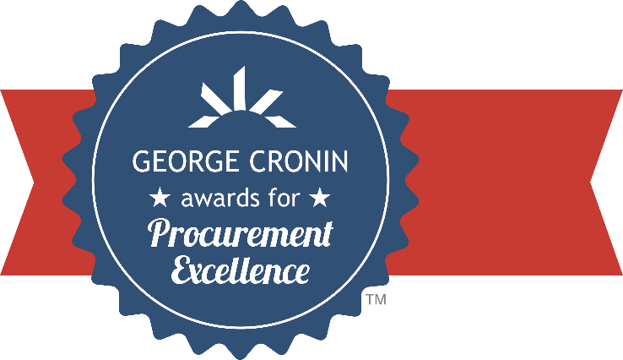

State of (Insert Name)
Department of (Insert Name)
Division of (Insert Name)

2024 George Cronin Awards for Procurement Excellence

Enter Submission Title Here

Use this template to help guide you as you prepare your submission for review by the Cronin Awards Committee. It is recommended that you keep the headings as they are provided in this template. This will make it easier for committee members as they review submissions. Feel free to delete the guideline text as you go through this template, it is just there to help you understand how the committee evaluates each category.

Scoring Methodology
The scoring methodology used in the George Cronin Awards for Procurement Excellence is a two-phase approach:
Phase I: The committee will score the Innovation and Transferability categories only, after which a “Top Ten,” will be named based on the scores from those categories.
Once the submissions have been narrowed down, the Committee will develop questions to illicit clarity on elements of the submission. NASPO Committee Support Staff will reach out to the individual that submitted the Cronin Award nomination to have them submit, in writing, answers to the committee’s questions.
Phase II: Responses from the clarification questions are distributed to the committee, who then score the remaining two categories, Service Improvement and Savings & Efficiency, for the Top Ten named in Phase I.
Score cards are then calculated, and the five finalists are determined and ranked, based off each project aggregate total.

Executive Summary
The Cronin Awards evaluation consists of four categories, each one examining a different aspect of the project's impact, and each weighed separately to provide an overall score (more details available in the methodology subsection). Submissions are limited to four pages (not including cover/title page), although optional supporting material can also be submitted as a separate document when needed to showcase images, examples, or documentation that is too large to fit within the four-page submission itself. You do not need to include the instruction/description text found in each section of this template.
It is useful to committee members for a submission to begin with a concise introduction/executive summary that describes the purpose and scope of the project and gives a brief overview of the implementation process. The introduction should also include a summary statement of the content of each of the four categories and a comment on the results of the project. If there is anything in the submission to which committee members should pay particular attention, it is helpful to mention it in the introduction. This executive summary should not exceed one page and is included as part of the total pages for the submission.

Innovation
(30 points) – Unusual or unique approach, scale, or magnitude of effort; conceptual originality. This category should answer the question, “What makes this project stand out as a notable contribution to the procurement function?” It is intended to capture the nature and impact of changes in your state operations, but it also rewards path-breaking ideas or efforts that may not have been considered or attempted elsewhere. Because substantial originality is so rare, this category offers the highest potential point total to a submission that is able to point out differences and to distinguish itself from closely similar projects completed or underway in other states.

Transferability
(30 points) – primarily an external focus that assesses the practical ability by other states to replicate or use as a benchmark, considering expected resources required and generality of the legal or structural environment in which the entry was implemented. A project or initiative that can be used broadly by other states as a template will receive a higher score than one with benefits that appear to depend on the particular geography, environment, governmental structure, or particular needs of the submitting state. In some cases, it may be necessary to explain how an apparent state-bound effort can be adapted for greater transferability.

Service Improvement
(25 points) – an internal focus that assesses the extent to which transactions or service delivery is made more effective or efficient; includes consideration of nature of stakeholder involvement by agencies/users in development & implementation of program or project; change management strategy sufficient to promote adoption. Every purchasing organization provides a service to other state agencies, and this category is intended to assess results—the impact of the project on improving the delivery of those services. More weight is given to specifics than to generalities. When metrics are provided, it is beneficial to include a short (non-technical) explanation of how those metrics were produced. Also, committee members look favorably on descriptions of the input, participation, and adoption by stakeholders.

Savings & Efficiency
(15 points) – validated or potential for cost reduction, resource savings, and improved efficiency. Although these savings criteria may not be quite as highly weighted as the other three categories, well-documented estimates or projections of savings are often the determining factor between otherwise generally equal submissions. Savings and efficiency figures are given more weight when they are objective, supported by evidence, and include an explanation of how they were derived. Although increases in efficiency are less open to precise calculation, the manner or method by which the increase is realized should be described. In general, undocumented claims of very large cost reductions are less likely to receive higher scores than smaller, but significant and well-supported cost savings estimates.

Conclusion
Again, submissions are limited to four pages. You can also submit supplemental material if absolutely necessary, to showcase images, examples, or documentation that is too large to fit within the four-page submission itself. Please note, committee members are not required to carefully peruse often-voluminous supporting materials to properly understand or appreciate the nature and scope of the project. The four-page submission should make this clear on its own. Supporting materials should do just that—support and document the statements made and results described in the four-page submission itself and should only be used when absolutely necessary.
Once you are finished with your submission, you can export it as a PDF and upload it on the Cronin Awards page below using our online form.

Upload your submission here:
https://www.naspo.org/awards/george-cronin-awards/how-to-apply/

