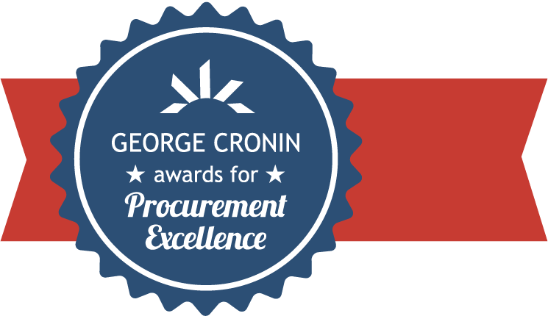

State of Florida
Department of Management Services
Division of State Purchasing

2019 George Cronin Awards for Procurement Excellence

Market Analysis and Procurement Strategy (MAPS)

Executive Summary
The Florida Department of Management Services (DMS), Division of State Purchasing utilizes the Market Analysis and Procurement Strategy (MAPS) process to determine which procurement method to employ and to achieve a best value for Florida. The MAPS process is used in determining if the Department should issue a new, competitive solicitation (purchases exceeding Category II, $35,000), to re-solicit an existing contract, to renew an existing contract or to allow an existing contract to expire. The MAPS processes resemble a research paper which highlights the following sections: background information, the current industry, customer and vendor information, pricing analysis to determine pricing of comparable contracts, risk assessment, special circumstances and a recommendation. The MAPS is an excellent tool for determining past procurement decisions and for determining what course of action is needed for future purchases, always keeping State of Florida customers in mind.
Innovation
The MAPS document is an innovative resource for procurement, which highlights critical information in a simple layout using visual aids, and legible wording. Through easy to digest tables and graphs, this design offers an all-encompassing view of top spend from Florida customers, to include state agencies and eligible users (cities, counties, local governments, etc.). The visual aids also report on top spend by vendors and which vendors are dominating the market. Florida also uses several resources to collect information reported in the MAPS including GovWin Reporting, ProcurementIQ, validating contract pricing from consortia such as NASPO, Sourcewell, OMNIA and sister states of similar size and scope to Florida, such as California, Texas and New York.
Below is an example of the Office Supplies MAPS comparing spend by product category and by customers:

Transferability
In August 2018, Florida was asked by the National Institute of Governmental Purchasing (NIGP) to present on “Florida’s Market Research: How it can empower you to make smart decisions” webinar. Florida expounded upon the MAPS process and received positive feedback from the 350 attendees. In September 2018, Florida partnered with NASPO and ProcurementIQ to train several states on the MAPS process. Florida fulfilled numerous requests for Florida’s MAPS template and received outstanding feedback from conducting the presentation.
Florida’s MAPS can be used and adapted by other states. Due to the readily available information that a MAPS can provide, it can easily be transposed and adjusted for use by other states. For more state-specific data, the pricing analysis can be used to verify if the recommended action is in the best interest of that state. Using available charts and graphs, one can surmise cost effectiveness and best value for their procurement.
Additionally, the MAPS process can also easily adapt to help other states’ determine the best method of procurement for their particular need. In Florida, which uses three primary methods of competitive procurement, MAPS helps our solidify our understanding of the procurement need and scope of services or commodities being sought. We use insight into our state agencies’ spend and other analytics to determine the most appropriate method of procurement.
Service Improvement
In terms of functionality, the simple layout of Florida’s MAPS process allows for the adaptation and/or addition of information as it is well organized making these changes readily accessible. Through the MAPS process, the Department ensures that our procurements best meet the needs of our customers by producing high-quality contracts with pricing discounts better than other industry agreements. This allows our customers to meet and exceed customers’ needs more effectively.
Also as mentioned above, the use of MAPS improves our method of procurement selection, thus reducing staff time spent in solicitation development, legal review, and routing for approval. As an example, for a recent state term contract that was nearing expiration, the procurement staff drafted a MAPS and determined that a cooperative purchasing agreement achieved best overall value for the state. This assessment eliminated the need to draft and implement a request for proposals, saving nearly nine months of staff time, and providing a solution that achieved significant cost savings to our agencies with a much more rapid turnaround time.
The final improvement that Florida has realized through use of MAPS is the historical value of the documentation. When approaching a new procurement, we have prior MAPS documentation that demonstrates prior decision-making, references existing markets, and illustrates changes in those markets since the prior procurement. These “roadmaps” have proven to be of benefit as documenting lessons learned and helping memorialize best practices within individual procurements.
Cost Reduction
MAPS have consistently proven to be cost effective. The State of Florida reports on Key Performance Indicators (KPIs) on a quarterly basis, measuring our success in meeting or exceeding pricing for comparable contracts. While it is difficult to track specific cost savings and cost avoidance, the most recent data from our KPI shows that:
- During fiscal year 2018-19, all of the contracts procured by the division achieved pricing that was better than or equal to similar contracts procured by consortia (e.g. Sourcewell) and states of similar size (e.g. California, Texas, and New York).
- During fiscal year 2018-19, state agencies and eligible users realized actual savings of approximately 38.5% over retail or other referenced prices using contracts procured by the division for various commodities and contractual services.

